LR Parser

LR parsing is one type of bottom up parsing. It is used to parse the large class of grammars.

In the LR parsing, "L" stands for left-to-right scanning of the input.

"R" stands for constructing a right most derivation in reverse.

"K" is the number of input symbols of the look ahead used to make number of parsing decision.

6.2M

116

Difference between JDK, JRE, and JVM

LR parsing is divided into four parts: LR (0) parsing, SLR parsing, CLR parsing and LALR parsing.

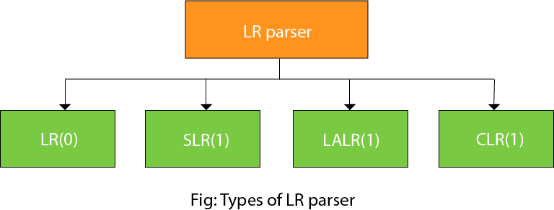

LR algorithm:

The LR algorithm requires stack, input, output and parsing table. In all type of LR parsing, input, output and stack are same but parsing table is different.

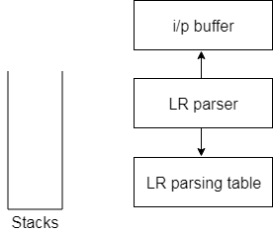

**Fig: Block diagram of LR parser**

Input buffer is used to indicate end of input and it contains the string to be parsed followed by a $ Symbol.

A stack is used to contain a sequence of grammar symbols with a $ at the bottom of the stack.

Parsing table is a two dimensional array. It contains two parts: Action part and Go To part.

LR (1) Parsing

Various steps involved in the LR (1) Parsing:

* For the given input string write a context free grammar.
* Check the ambiguity of the grammar.
* Add Augment production in the given grammar.
* Create Canonical collection of LR (0) items.
* Draw a data flow diagram (DFA).
* Construct a LR (1) parsing table.

Augment Grammar

Augmented grammar G` will be generated if we add one more production in the given grammar G. It helps the parser to identify when to stop the parsing and announce the acceptance of the input.

Example

Given grammar

1. S → AA
2. A → aA | b

The Augment grammar G` is represented by

1. S`→ S
2. S → AA
3. A → aA | b

Canonical Collection of LR(0) items

An LR (0) item is a production G with dot at some position on the right side of the production.

LR(0) items is useful to indicate that how much of the input has been scanned up to a given point in the process of parsing.

In the LR (0), we place the reduce node in the entire row.

Example

Given grammar:

1. S → AA
2. A → aA | b

Add Augment Production and insert '•' symbol at the first position for every production in G

1. S` → •S
2. S → •AA
3. A → •aA
4. A → •b

I0 State:

Add Augment production to the I0 State and Compute the Closure

I0 = Closure (S` → •S)

Add all productions starting with S in to I0 State because "•" is followed by the non-terminal. So, the I0 State becomes

**I0 =** S` → •S  
       S → •AA

Add all productions starting with "A" in modified I0 State because "•" is followed by the non-terminal. So, the I0 State becomes.

**I0=** S` → •S  
       S → •AA  
       A → •aA  
       A → •b

**I1=** Go to (I0, S) = closure (S` → S•) = S` → S•

Here, the Production is reduced so close the State.

**I1=** S` → S•

**I2=** Go to (I0, A) = closure (S → A•A)

Add all productions starting with A in to I2 State because "•" is followed by the non-terminal. So, the I2 State becomes

**I2 =**S→A•A  
       A → •aA  
       A → •b

Go to (I2,a) = Closure (A → a•A) = (same as I3)

Go to (I2, b) = Closure (A → b•) = (same as I4)

**I3=** Go to (I0,a) = Closure (A → a•A)

Add productions starting with A in I3.

A → a•A  
A → •aA  
A → •b

Go to (I3, a) = Closure (A → a•A) = (same as I3)  
Go to (I3, b) = Closure (A → b•) = (same as I4)

**I4=** Go to (I0, b) = closure (A → b•) = A → b•  
**I5=** Go to (I2, A) = Closure (S → AA•) = SA → A•  
**I6=** Go to (I3, A) = Closure (A → aA•) = A → aA•

Drawing DFA:

The DFA contains the 7 states I0 to I6.

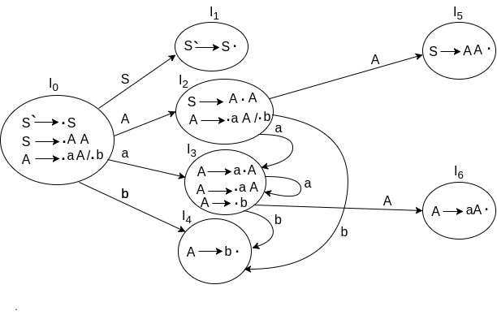

LR(0) Table

* If a state is going to some other state on a terminal then it correspond to a shift move.
* If a state is going to some other state on a variable then it correspond to go to move.
* If a state contain the final item in the particular row then write the reduce node completely.

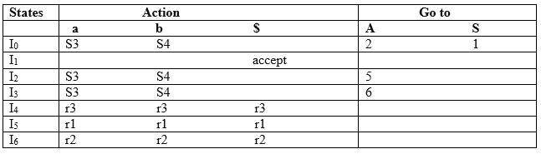

**Explanation:**

* I0 on S is going to I1 so write it as 1.
* I0 on A is going to I2 so write it as 2.
* I2 on A is going to I5 so write it as 5.
* I3 on A is going to I6 so write it as 6.
* I0, I2and I3on a are going to I3 so write it as S3 which means that shift 3.
* I0, I2 and I3 on b are going to I4 so write it as S4 which means that shift 4.
* I4, I5 and I6 all states contains the final item because they contain • in the right most end. So rate the production as production number.

Productions are numbered as follows:

1. S  →      AA    ... (1)
2. A   →     aA      ... (2)
3. A    →    b     ... (3)

* I1 contains the final item which drives(S` → S•), so action {I1, $} = Accept.
* I4 contains the final item which drives A → b• and that production corresponds to the production number 3 so write it as r3 in the entire row.
* I5 contains the final item which drives S → AA• and that production corresponds to the production number 1 so write it as r1 in the entire row.
* I6 contains the final item which drives A → aA• and that production corresponds to the production number 2 so write it as r2 in the entire row.

SLR (1) Parsing

SLR (1) refers to simple LR Parsing. It is same as LR(0) parsing. The only difference is in the parsing table. To construct SLR (1) parsing table, we use canonical collection of LR (0) item.

In the SLR (1) parsing, we place the reduce move only in the follow of left hand side.

Various steps involved in the SLR (1) Parsing:

* For the given input string write a context free grammar
* Check the ambiguity of the grammar
* Add Augment production in the given grammar
* Create Canonical collection of LR (0) items
* Draw a data flow diagram (DFA)
* Construct a SLR (1) parsing table

SLR (1) Table Construction

The steps which use to construct SLR (1) Table is given below:

If a state (Ii) is going to some other state (Ij) on a terminal then it corresponds to a shift move in the action part.

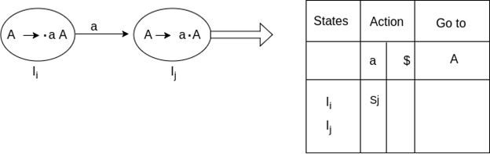

If a state (Ii) is going to some other state (Ij) on a variable then it correspond to go to move in the Go to part.

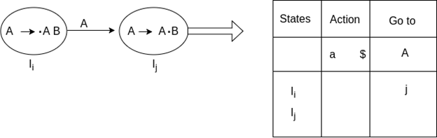

If a state (Ii) contains the final item like A → ab• which has no transitions to the next state then the production is known as reduce production. For all terminals X in FOLLOW (A), write the reduce entry along with their production numbers.

Example

1. S -> •Aa
2. A->αβ•
3. Follow(S) = {$}
4. Follow (A) = {a}

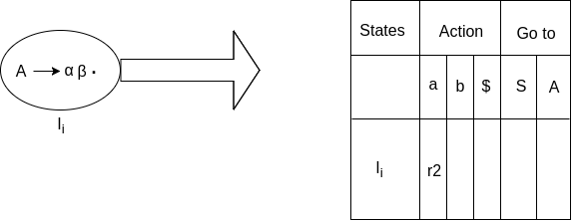

SLR ( 1 ) Grammar

S → E  
E → E + T | T  
T → T * F | F  
F → id

Add Augment Production and insert '•' symbol at the first position for every production in G

S` → •E  
E → •E + T  
E → •T  
T → •T * F  
T → •F  
F → •id

**I0 State:**

Add Augment production to the I0 State and Compute the Closure

**I0 =** Closure (S` → •E)

Add all productions starting with E in to I0 State because "." is followed by the non-terminal. So, the I0 State becomes

**I0 =** S` → •E  
        E → •E + T  
        E → •T

Add all productions starting with T and F in modified I0 State because "." is followed by the non-terminal. So, the I0 State becomes.

**I0=** S` → •E  
       E → •E + T  
       E → •T  
       T → •T * F  
       T → •F  
       F → •id

**I1=** Go to (I0, E) = closure (S` → E•, E → E• + T)  
**I2=** Go to (I0, T) = closure (E → T•T, T• → * F)  
**I3=** Go to (I0, F) = Closure ( T → F• ) = T → F•  
**I4=** Go to (I0, id) = closure ( F → id•) = F → id•  
**I5=** Go to (I1, +) = Closure (E → E +•T)

Add all productions starting with T and F in I5 State because "." is followed by the non-terminal. So, the I5 State becomes

**I5 =** E → E +•T  
       T → •T * F  
       T → •F  
       F → •id

Go to (I5, F) = Closure (T → F•) = (same as I3)  
Go to (I5, id) = Closure (F → id•) = (same as I4)

**I6=** Go to (I2, *) = Closure (T → T * •F)

Add all productions starting with F in I6 State because "." is followed by the non-terminal. So, the I6 State becomes

**I6 =** T → T * •F  
         F → •id

Go to (I6, id) = Closure (F → id•) = (same as I4)

**I7=** Go to (I5, T) = Closure (E → E + T•) = E → E + T•  
**I8=** Go to (I6, F) = Closure (T → T * F•) = T → T * F•

Drawing DFA:

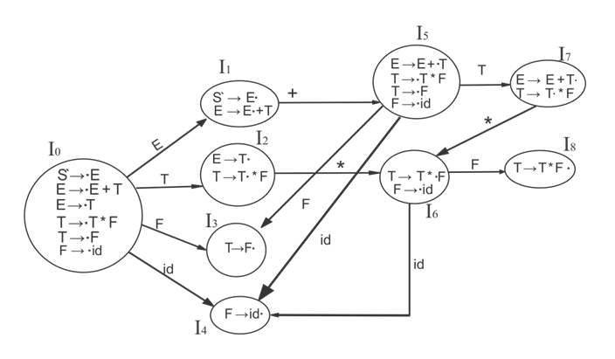

SLR (1) Table

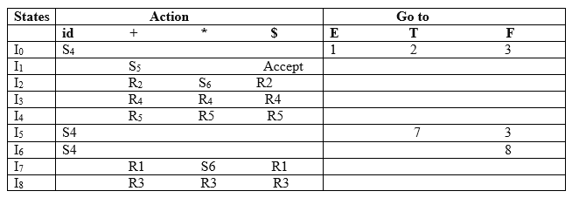

Explanation:

First (E) = First (E + T) ∪ First (T)  
First (T) = First (T * F) ∪ First (F)  
First (F) = {id}  
First (T) = {id}  
First (E) = {id}  
Follow (E) = First (+T) ∪ {$} = {+, $}  
Follow (T) = First (*F) ∪ First (F)  
               = {*, +, $}  
Follow (F) = {*, +, $}

* I1 contains the final item which drives S → E• and follow (S) = {$}, so action {I1, $} = Accept
* I2 contains the final item which drives E → T• and follow (E) = {+, $}, so action {I2, +} = R2, action {I2, $} = R2
* I3 contains the final item which drives T → F• and follow (T) = {+, *, $}, so action {I3, +} = R4, action {I3, *} = R4, action {I3, $} = R4
* I4 contains the final item which drives F → id• and follow (F) = {+, *, $}, so action {I4, +} = R5, action {I4, *} = R5, action {I4, $} = R5
* I7 contains the final item which drives E → E + T• and follow (E) = {+, $}, so action {I7, +} = R1, action {I7, $} = R1
* I8 contains the final item which drives T → T * F• and follow (T) = {+, *, $}, so action {I8, +} = R3, action {I8, *} = R3, action {I8, $} = R3.

CLR (1) Parsing

CLR refers to canonical lookahead. CLR parsing use the canonical collection of LR (1) items to build the CLR (1) parsing table. CLR (1) parsing table produces the more number of states as compare to the SLR (1) parsing.

In the CLR (1), we place the reduce node only in the lookahead symbols.

Various steps involved in the CLR (1) Parsing:

* For the given input string write a context free grammar
* Check the ambiguity of the grammar
* Add Augment production in the given grammar
* Create Canonical collection of LR (0) items
* Draw a data flow diagram (DFA)
* Construct a CLR (1) parsing table

**LR (1) item**

LR (1) item is a collection of LR (0) items and a look ahead symbol.

**LR (1) item = LR (0) item + look ahead**

The look ahead is used to determine that where we place the final item.

The look ahead always add $ symbol for the argument production.

Example

**CLR ( 1 ) Grammar**

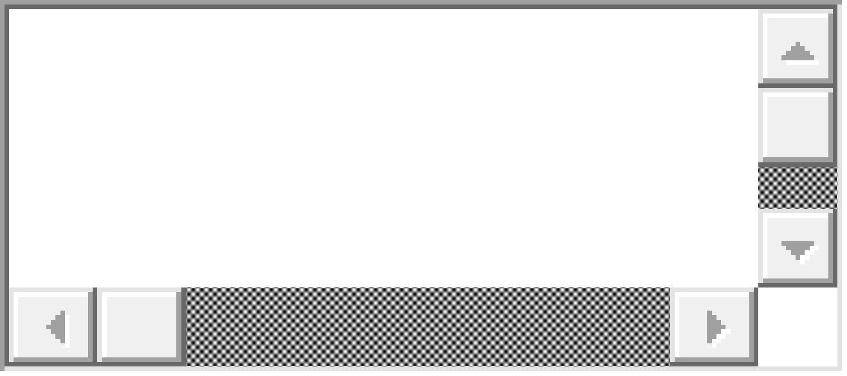

Add Augment Production, insert '•' symbol at the first position for every production in G and also add the lookahead.



**I0 State:**

Add Augment production to the I0 State and Compute the Closure

**I0 =** Closure (S` → •S)

Add all productions starting with S in to I0 State because "." is followed by the non-terminal. So, the I0 State becomes

**I0 =** S` → •S, $  
        S → •AA, $

Add all productions starting with A in modified I0 State because "." is followed by the non-terminal. So, the I0 State becomes.

**I0=**  S` → •S, $  
        S → •AA, $  
        A → •aA, a/b  
        A → •b, a/b

**I1=** Go to (I0, S) = closure (S` → S•, $) = S` → S•, $  
**I2=** Go to (I0, A) = closure ( S → A•A, $ )

Add all productions starting with A in I2 State because "." is followed by the non-terminal. So, the I2 State becomes

**I2=** S → A•A, $  
       A → •aA, $  
       A → •b, $

**I3=** Go to (I0, a) = Closure ( A → a•A, a/b )

Add all productions starting with A in I3 State because "." is followed by the non-terminal. So, the I3 State becomes

**I3=**A → a•A, a/b  
       A → •aA, a/b  
       A → •b, a/b

Go to (I3, a) = Closure (A → a•A, a/b) = (same as I3)  
Go to (I3, b) = Closure (A → b•, a/b) = (same as I4)

**I4=** Go to (I0, b) = closure ( A → b•, a/b) = A → b•, a/b  
**I5=** Go to (I2, A) = Closure (S → AA•, $) =S → AA•, $  
**I6=** Go to (I2, a) = Closure (A → a•A, $)

Add all productions starting with A in I6 State because "." is followed by the non-terminal. So, the I6 State becomes

**I6 =** A → a•A, $  
       A → •aA, $  
       A → •b, $

Go to (I6, a) = Closure (A → a•A, $) = (same as I6)  
Go to (I6, b) = Closure (A → b•, $) = (same as I7)

**I7=** Go to (I2, b) = Closure (A → b•, $) = A → b•, $  
**I8=** Go to (I3, A) = Closure (A → aA•, a/b) = A → aA•, a/b  
**I9=** Go to (I6, A) = Closure (A → aA•, $) = A → aA•, $

Drawing DFA:

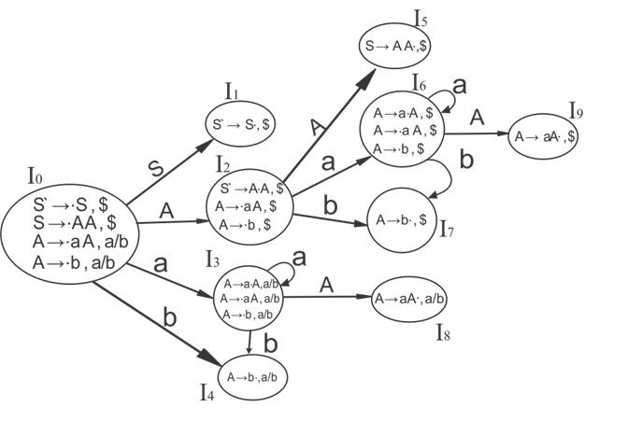

CLR (1) Parsing table:

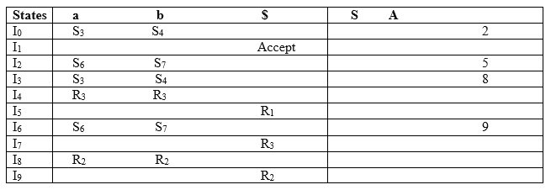

Productions are numbered as follows:



The placement of shift node in CLR (1) parsing table is same as the SLR (1) parsing table. Only difference in the placement of reduce node.

I4 contains the final item which drives ( A → b•, a/b), so action {I4, a} = R3, action {I4, b} = R3.  
I5 contains the final item which drives ( S → AA•, $), so action {I5, $} = R1.  
I7 contains the final item which drives ( A → b•,$), so action {I7, $} = R3.  
I8 contains the final item which drives ( A → aA•, a/b), so action {I8, a} = R2, action {I8, b} = R2.  
I9 contains the final item which drives ( A → aA•, $), so action {I9, $} = R2.

LALR (1) Parsing:

LALR refers to the lookahead LR. To construct the LALR (1) parsing table, we use the canonical collection of LR (1) items.

In the LALR (1) parsing, the LR (1) items which have same productions but different look ahead are combined to form a single set of items

LALR (1) parsing is same as the CLR (1) parsing, only difference in the parsing table.

Example

**LALR ( 1 ) Grammar**

1. S → AA
2. A  → aA
3. A → b

Add Augment Production, insert '•' symbol at the first position for every production in G and also add the look ahead.

1. S` → •S, $
2. S  → •AA, $
3. A  → •aA, a/b
4. A  → •b, a/b

**I0 State:**

Add Augment production to the I0 State and Compute the ClosureL

**I0 =** Closure (S` → •S)

Add all productions starting with S in to I0 State because "•" is followed by the non-terminal. So, the I0 State becomes

**I0 =**S` → •S, $  
        S → •AA, $

Add all productions starting with A in modified I0 State because "•" is followed by the non-terminal. So, the I0 State becomes.

**I0=** S` → •S, $  
       S → •AA, $  
       A → •aA, a/b  
       A → •b, a/b

**I1=** Go to (I0, S) = closure (S` → S•, $) = S` → S•, $  
**I2=** Go to (I0, A) = closure ( S → A•A, $ )

Add all productions starting with A in I2 State because "•" is followed by the non-terminal. So, the I2 State becomes

**I2=** S → A•A, $  
       A → •aA, $  
       A → •b, $

**I3=** Go to (I0, a) = Closure ( A → a•A, a/b )

Add all productions starting with A in I3 State because "•" is followed by the non-terminal. So, the I3 State becomes

**I3=** A → a•A, a/b  
       A → •aA, a/b  
       A → •b, a/b

Go to (I3, a) = Closure (A → a•A, a/b) = (same as I3)  
Go to (I3, b) = Closure (A → b•, a/b) = (same as I4)

**I4=** Go to (I0, b) = closure ( A → b•, a/b) = A → b•, a/b  
**I5=** Go to (I2, A) = Closure (S → AA•, $) =S → AA•, $  
**I6=** Go to (I2, a) = Closure (A → a•A, $)

Add all productions starting with A in I6 State because "•" is followed by the non-terminal. So, the I6 State becomes

**I6 =** A → a•A, $  
       A → •aA, $  
       A → •b, $

Go to (I6, a) = Closure (A → a•A, $) = (same as I6)  
Go to (I6, b) = Closure (A → b•, $) = (same as I7)

**I7=** Go to (I2, b) = Closure (A → b•, $) = A → b•, $  
**I8=** Go to (I3, A) = Closure (A → aA•, a/b) = A → aA•, a/b  
**I9=** Go to (I6, A) = Closure (A → aA•, $) A → aA•, $

If we analyze then LR (0) items of I3 and I6 are same but they differ only in their lookahead.

**I3 =** { A → a•A, a/b  
      A → •aA, a/b  
      A → •b, a/b  
       }

**I6=** { A → a•A, $  
      A → •aA, $  
      A → •b, $  
      }

Clearly I3 and I6 are same in their LR (0) items but differ in their lookahead, so we can combine them and called as I36.

**I36 =** { A → a•A, a/b/$  
       A → •aA, a/b/$  
       A → •b, a/b/$  
        }

The I4 and I7 are same but they differ only in their look ahead, so we can combine them and called as I47.

**I47 =** {A → b•, a/b/$}

The I8 and I9 are same but they differ only in their look ahead, so we can combine them and called as I89.

**I89 =** {A → aA•, a/b/$}

Drawing DFA:

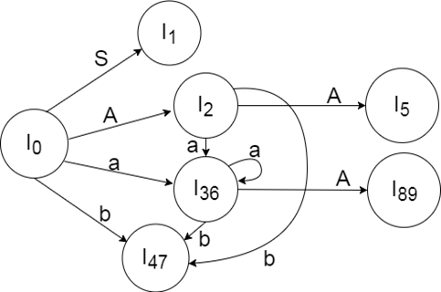

LALR (1) Parsing table:

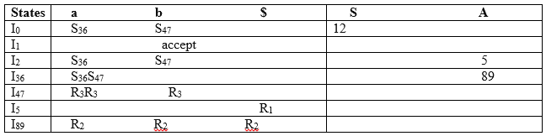

# Regular Grammar

A grammar is said to be regular, if the production is in the form -

##### **A → αB,**

##### **A -> a,**

##### **A → ε,**

##### for **A, B ∈ N, a ∈ Σ,** and **ε the empty string**

A regular grammar is a 4 tuple -

##### **G = (V, Σ, P, S)**

**V**- It is non-empty, finite set of non-terminal symbols,  
**Σ**- finite set of terminal symbols, **(Σ ∈ V)**,  
**P**- a finite set of productions or rules,  
**S** - start symbol, **S ∈ (V - Σ)**

## Regular Language

A language **L(G)** generated by **G** -

##### **L(G) = {w | S ⇒ * w, where w ∈ Σ*}**

The symbol w is the set of all strings over the alphabet **Σ** and **S** is the start symbol.

The language generated by regular grammar can be recognized by DFA's, NFA's.

# Unrestricted Grammar

In automaton, **Unrestricted Grammar** or **Phrase Structure Grammar** is most general in the **Chomsky Hierarchy of classification**. This is **type0** grammar, generally used to generate **Recursively Enumerable languages**. It is called unrestricted because no other restriction in made on this except each of their left hand sides being non empty. The left hand sides of the rules can contain terminal and non terminal, but the condition is at least of them must be non terminal.

A **Turning Machine** can simulate an **Unrestricted Grammar** and an **Unrestricted Grammar** can simulate **Turning Machine** configurations. It can always be found for the language recognized or generated by any **Turning Machine**.

## Formal Definition

The unrestricted grammar is 4 tuple -

### G = (N,Σ,P,S)

**N** - A finite set of **non-terminal** symbols or **variables**,  
**Σ** - It is a set of terminal symbols or alphabet of the language being described, where **N ∩ Σ = φ**,  
**P** - It is a finite set of "**productions**" or "**rules**",  
**S** - It is a **start variable** or **non terminal** symbols.

If, **α** and **β** are two strings over the alphabet **N ∪ Σ**. Then, the rules or productions are of the form **α → β**. The start variable **S** appears on the left side of the rule.

## Example of Unrestricted Grammar

### Language

##### **L={anbncn | n≥0}**

### Grammar

##### **S→aBSc {Equal Number** of **a's, B's, c's}**

##### **S→ ε {Eliminate S}**

##### **Ba→aB {Move a's to Right** of **B's}**

##### **Bc→bc {Reduce B before first c to b}**

##### 

##### **Bb→bb {Reduce all remaining B's to b}**

# Context Sensitive Grammar

The **Context Sensitive Grammar** is a formal grammar surrounded by a context of **terminal** and **non-terminal** grammar. It is less general than Unrestricted Grammar and more general than Context Free Grammar.

The context-sensitive grammar was introduced by **Noam Chomsky** in the 1950.

## Formal definition of Context-Sensitive Grammar

The formal definition of Context Sensitive Grammar are as follows. It is 4 tuple-

### G = (N,Σ,P,S)

**N** - It is a set of non-terminal symbols,  
**Σ** - It is a set of terminal symbols,  
**P** - It is a set of production rules,  
**S** - It is a start symbol of the production.

It is context sensitive, if all the rules in production are in the form -

##### **αAβ → αγβ**

where,

##### A **∈ N,**

##### **α,β ∈ (N∪Σ)*,**

##### **γ ∈ (N∪Σ)+**

and, A is non-terminal.

The language generated by the context-sensitive grammar is called **Context Sensitive Language**.

## Example of Context-Sensitive Grammar

Suppose, **P** is set of rules and a context-sensitive grammar **G** is -

##### **G = {{S, A,B,C,a,b,c},{a,b,c},P,S}**

##### S **-> aSBC**

##### **S -> aBC**

##### **CB -> BC**

##### **aB -> ab**

##### **bB -> bb**

##### **bC -> bc**

##### **cC -> cc**

Then, the language generated by the grammar G is -

##### **{anbncn|n >= 1}**